Assignment 6:

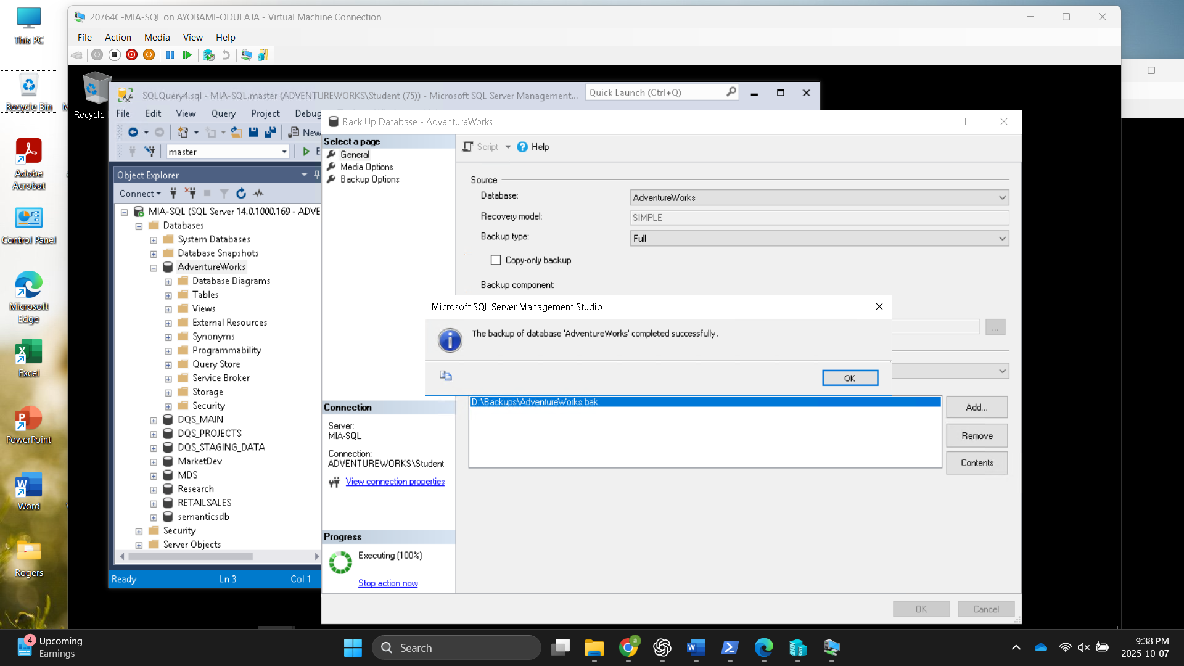

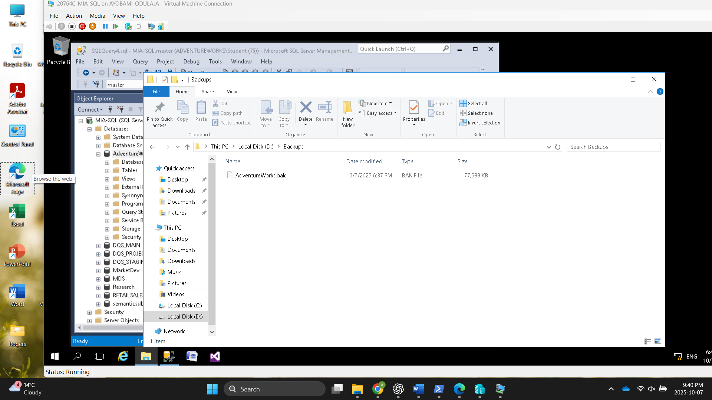

Size is 77,589KB

Create a T-SQL statement that creates a full backup of the Research database that you modified for the last chapter and saves it to the c:\database-backups\Research folder.

